***Design and Analysis of Algorithms CS575, Spring 2023***

Theory Assignment 2.3

**Due on 3/20/23 (Monday)**

1. (14 points) Use the radix sort algorithm to sort the following numbers. Treat every data as a 3- digit integer.

456, 329, 478, 59, 52, 447, 380, 126, 237, 599, 626, 255.

* 1. Draw a figure to show the actions step by step (see example figure in slide 50 or 51 of Ch6-sorting-heap-linear lecture notes) by treating each digit as a “digit”. (5 points)
  2. Explain why stable sorting at each step is important. You just need to state that correctness cannot be guaranteed (by giving an example) if you did not apply stable sorting at that step (5 points).
  3. Describe what conditions should be met for radix sort to be O(n)? (4 points)

Solution:

1a.

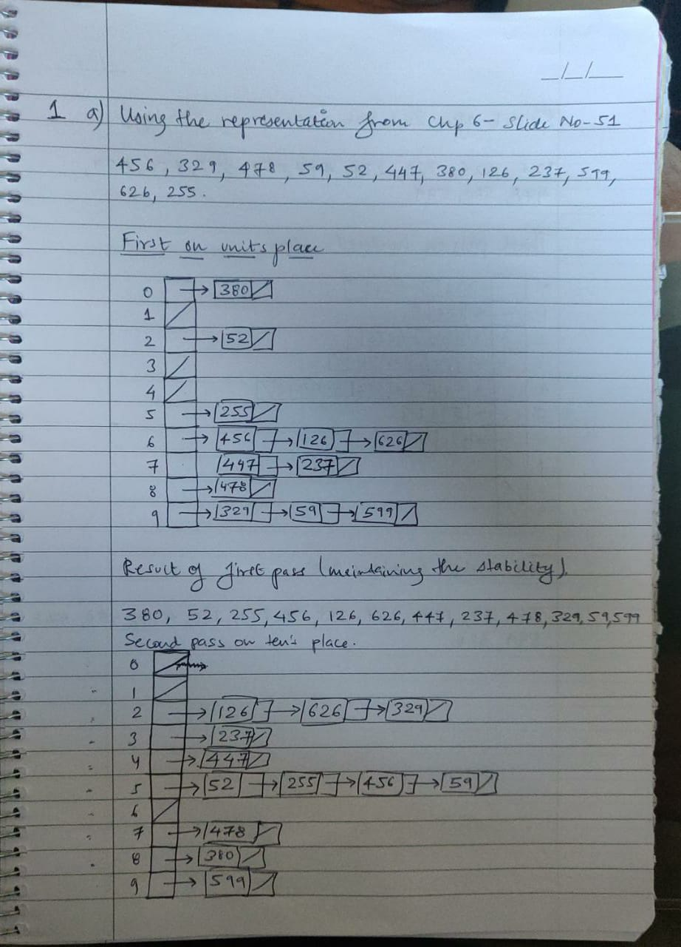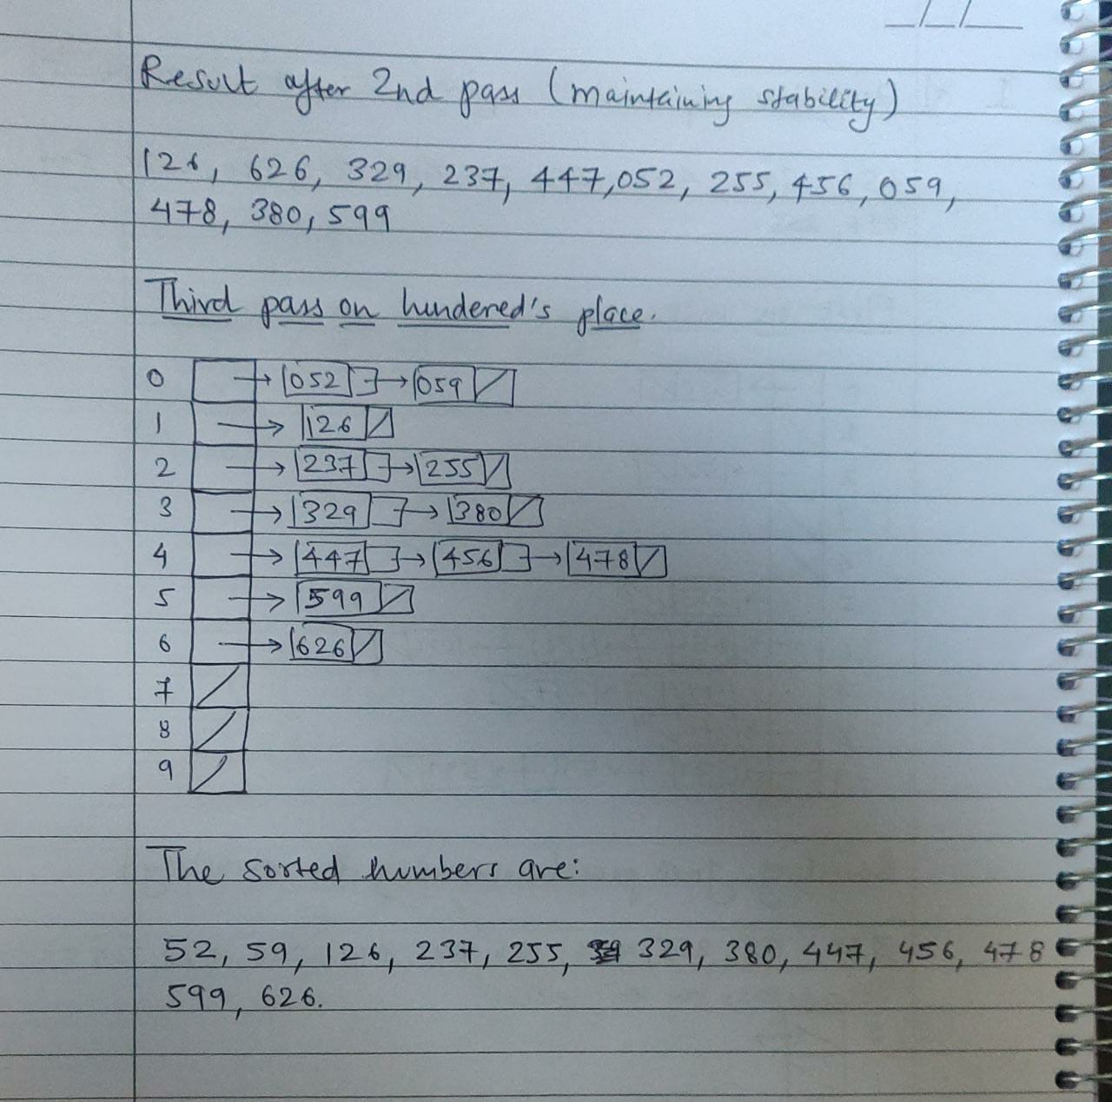

1b. 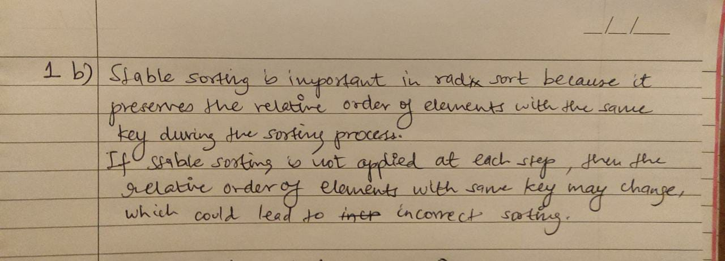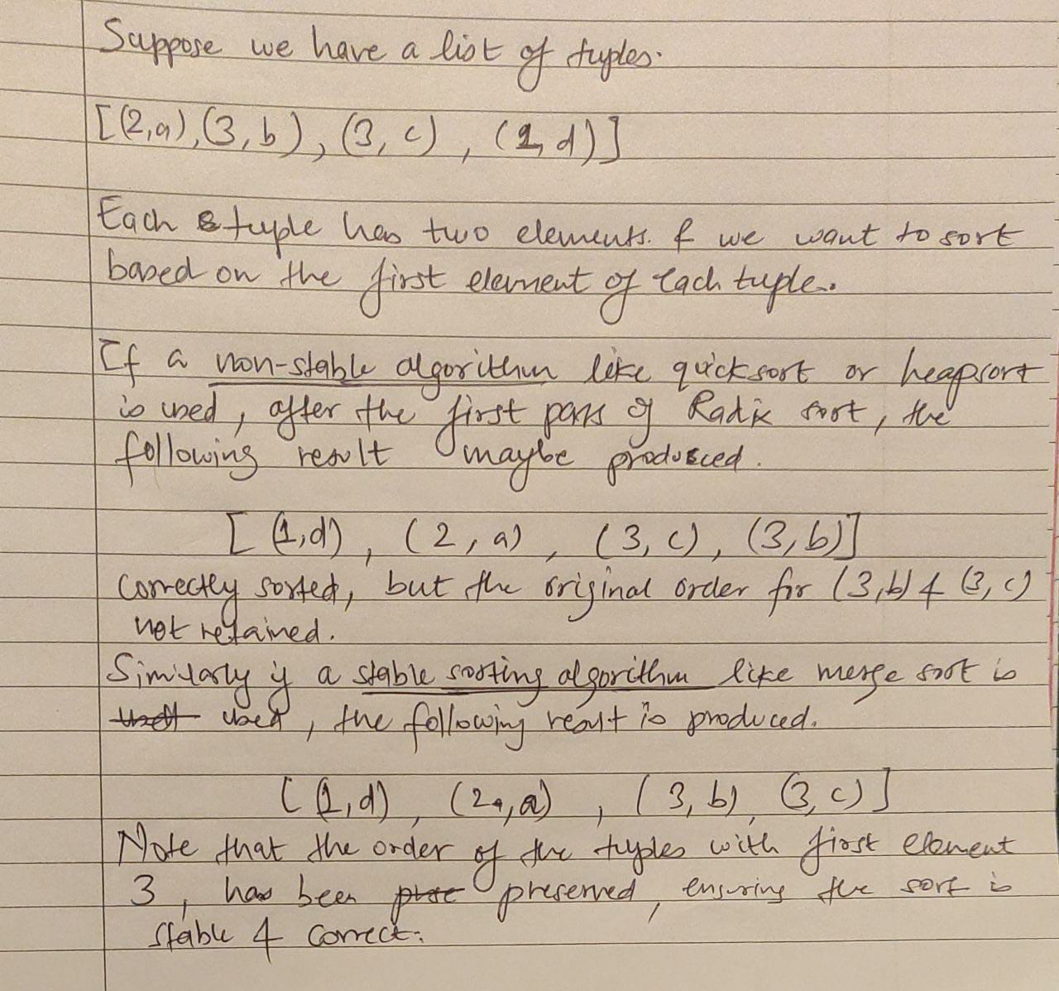

1c

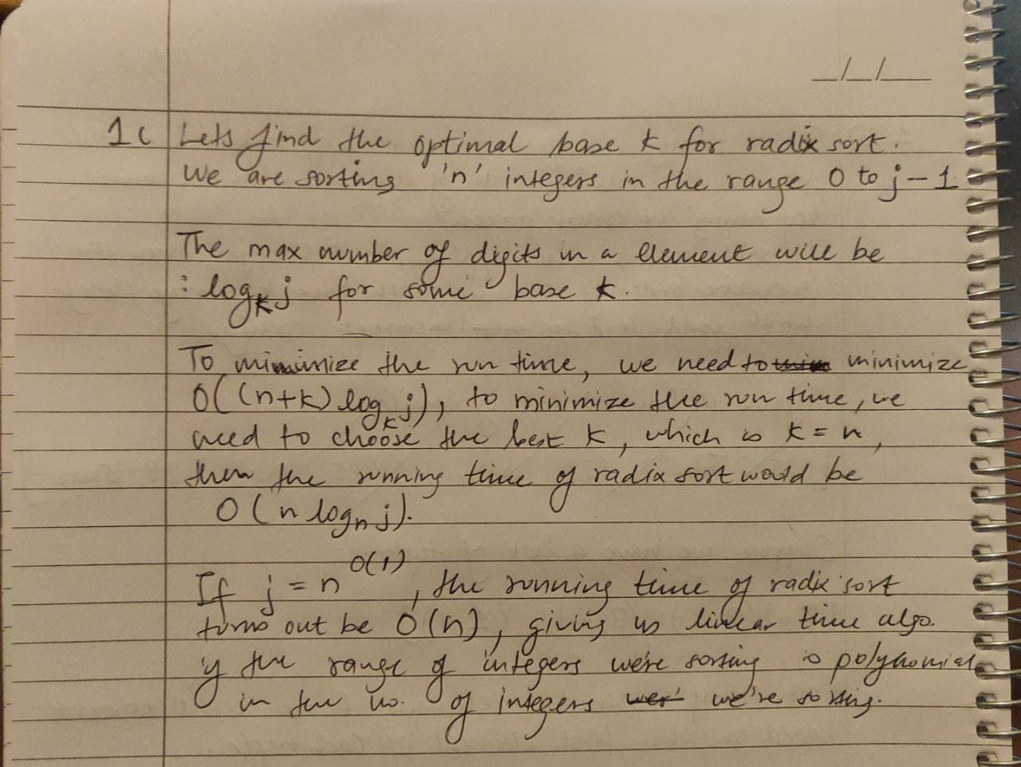

1. (14 points) Suppose we want to apply Radix Sort to sort 100,000 4-letter words with each letter taken from the English alphabet (26 letters, all lower cases). Assuming that the running time for sorting *n* elements within range 1..*k* using Counting Sort is 2*n*+2*k*, calculate the running time for each of the following strategies a), b) and c). Show the justification.
   1. treat letters at each of the four positions as a digit. (4 points)
   2. treat 2-letter sub-words at positions 1-2 as a digit and 2-letter sub-words at positions 3- 4 as another digit. (4 points)
   3. treat all 4 letters as a digit. (4 points)
   4. which strategy is the best strategy to minimize the running time? (2 points)

Solution:

